Appendix 1: LASER market performance Oct 2011 to Sept 2014

LASER’s average electricity purchase price was 1.3% below the average market price in the Purchase in Advance (PIA) energy basket. Performance over the last three years is illustrated in the chart below
.
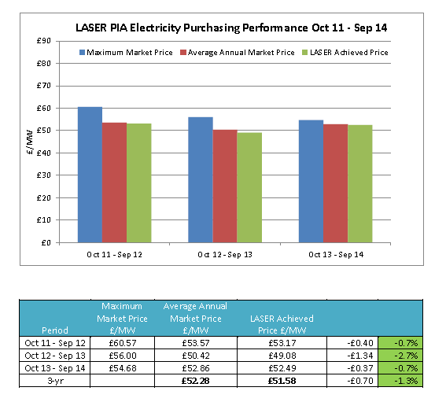

LASER’s average gas purchase price was 0.6% below the average market price in the Purchase in Advance (PIA) energy basket. Performance over the last three years is illustrated in the chart below.
